**RESOLUTION NO. 11/08/2024-01**

**RESOLUTION OF APPLICATION BY THE PENINSULA FIRE DISTRICT BOARD OF DIRECTORS REQUESTING THE PLUMAS LOCAL AGENCY FORMATION COMMISSION TO INITIATE PROCEEDINGS FOR THE ANNEXATION OF CHESTER PUBLIC UTILITY DISTRICT FIRE SERVICES TERRITORY TO THE PENINSULA FIRE PROTECTION DISTRICT AND THE DISSOLUTION OF CHESTER PUBLIC UTILITY DISTRICT’S FIRE SERVICES TERRITORY**

**WHEREAS,** Peninsula Fire Protection District in conjunction with Chester Public Utility District approving substantially similar resolutions and listed within this resolution, desires to initiate proceedings pursuant to the Cortese-Knox-Hertzberg Local Government Reorganization Act of 2000, commencing with Section 56000 of the California Government Code and California Health and Safety Code Sections 13800-13970, also known as the Fire Protection District Law of 1987, for the annexation of Chester Public Utility District’s fire services territory to the Peninsula Fire Protection District and the concurrent dissolution of the Chester Public Utility District’s fire services territory with transfer of responsibility to provide fire protection, emergency medical and rescue services contingent upon the annexation request as authorized by the Plumas Local Agency Formation Commission (LAFCo) and approved by the board of directors of Chester Public Utility District and the board of directors of Peninsula Fire Protection District; and

**WHEREAS**, Peninsula Fire Protection District ( PFPD) and the Chester Public Utility District, (CPUD) hereinafter referred to as “Participating Fire Agencies,” are authorized to provide fire protection, emergency medical and rescue services within their respective boundaries directly or by contract based on their respective formation documents and principal acts (California Government Code Section 38600, et seq., and California Health and Safety Code Section 13800, et seq.); and

**WHEREAS**, the Chester Public Utility District Board of Directors discovered serious issues within the department relating to lack of certain and adequate funding for Fire Department and EMS operations. Due to the CPUD Fire Department’s historical dependence on one-time funds to finance standard operations, the Fire Department routinely financed itself by borrowing money from the CPUD Sewer Department reserves, which as of September 30, 2024 has resulted in a debt owed by the CPUD Fire Department to the CPUD Sewer Department of $1,879,128.73. Because of the high cost of salaries and benefits that had been negotiated between CPUD’s Fire Department and the International Association of Firefighters Local 5317, CPUD was burdened by a structural deficit whereby the Fire Department spent approximately $2,000,000 annually to operate but only received annual tax revenues of $320,000 (a mixture of ad valorem taxes and a special parcel assessment – Measure A – which contains no sunset clause). After successfully cutting costs, CPUD determined that to continue providing fire protection and emergency medical response services throughout its territory, more revenue would need to be approved by the voters. The CPUD Board of Directors placed an additional parcel tax question on the November 2023 UDEL ballot, asking voters to approve a parcel tax valued between $350 and $400 per year per parcel, which voters did not approve. The CPUD Board of Directors then placed two competing tax measures on a May 2024 Special election ballot, asking voters to choose between having no fire department (not approving the tax), having a volunteer fire department and paying $450 per parcel per year (Measure B), or a full-service, full-time fire department and Advanced Life Support ambulance response for $1,500 per parcel per year (Measure C). Both Measures B and C failed to win voter approval. CPUD has laid off all non-administrative firefighting employees effective November 1, 2024. CPUD no longer has a contract with NorCal EMS, Inc. to provide ALS ground transportation; and

**WHEREAS**, on June 26, 2024, representatives from the boards of directors and staff of CPUD and PFPD met to discuss the feasibility of PFPD annexing CPUD’s fire services territory and in subsequent meetings invited Plumas County Local Agency Formation Commission (LAFCo) to provide information to achieve successful annexation; and

**WHEREAS**, on November 6, 2024 the Board of Directors of CPUD voted to support and pursue the annexation of CPUD’s fire services territory into the PFPD boundaries and service area to create an efficient, effective and sustainable emergency services system for the PFPD response area; and

**WHEREAS**, the Plumas LAFCo serves as the review authority over the formation and reorganization of cities and special districts as contained in and authorized by the Cortese-Knox-Hertzberg Local Government Reorganization Act of 2000, hereinafter referred to as “the Act”, commencing with Section 56000 of the California Government Code; and

**WHEREAS**, the Act establishes the process pursuant to which citizens or legislative bodies of local agencies may seek the reorganization of cities and districts; and

**WHEREAS**, in order to facilitate the annexation of CPUD’s fire services territory, through adoption of this resolution of application, the CPUD has assumed the principal role in initiating the proposal and requesting the Commission to commence its review process by the filing of an application with the appropriate fees paid by CPUD; and

**WHEREAS**, the proposed reorganization will be consistent with the adopted sphere of influence, updated by LAFCo, for CPUD’s fire services territory and ensuring there is no duplication of services within the resulting boundaries, through dissolution of CPUD’s fire services territory as indicated by the Municipal Services Review adopted for CPUD; and

**WHEREAS**, the PFPD sphere of influence will require amendment for consistency with the application; and

**WHEREAS**, notice of intent to adopt this resolution of application has been given, and this Board has conducted a public hearing based upon this notification, and has received and considered comments presented at that hearing; and

**WHEREAS**, the territory proposed to be annexed is considered to be inhabited (more than 12 registered voters) and a description of the boundaries of the territory to be included and a map of the proposed boundary designated as set forth in Exhibit ­#A, are attached hereto and by this reference incorporated herein; and

**WHEREAS**, the reasons for the proposed annexation are as follows:

1. CPUD’s fire services territory boundary lies as a separate but adjacent service area to the PFPD service boundaries. The two fire departments have historically worked very closely as the Almanor Basin’s only two emergency medical service agencies. Because of the complexities involved in running an Advanced Life Support (ALS) ground ambulance service, it is most logical to ask PFPD to expand their service territory than it is to seek an outside agency that would be able to provide both fire suppression and ALS ground transport.
2. Since February 29, 2024, PFPD has been responding to the vast majority of fire and emergency medical service calls within CPUD’s fire services territory as a result of CPUD fire staff layoffs; and

**WHEREAS,** it is desired to require that the proposed annexation be subject to the following Terms and Conditions:

1. A territorial new boundary be established for PFPD as identified in Exhibit #A, map and legal description of boundaries of the combined territories, including those territories currently within CPUD’s Sphere of Influence.
2. CPUD’s fire services territory and powers be dissolved, and PFPD named the successor, including all rights, responsibilities, contracts, assets and liabilities, and functions of the CPUD Fire Department and any funds to which it succeeds – with the exception of those items specified in Item 6a-d below – and may be expended and properly disposed of as provided by Division 12, Part 2.7, Chapter 1, Health & Safety Code, Fire Protection District Law of 1987 (commencing with Section 13800 et seq.), as itemized in Asset Transfer Schedules Exhibit #C­­­­.
3. PFPD, the successor agency, shall function under and carry out all authorized duties and responsibilities assigned to a Fire Protection District as outlined in the Division 12, Part 2.7, Chapter 1, Health & Safety Code, Fire Protection District Law of 1987 (commencing with Section 13800 et seq.) and other applicable laws.
4. If necessary, a tax exchange agreement shall be negotiated with the County of Plumas to allocate a property tax revenue structure for the PFPD to the successor agency, as provided for in Government Code Section 56810.
5. Pursuant to Government Code section 57330, owners of developed and undeveloped parcels within the newly adjust boundaries of PFPD will be assessed a 2021 voter approved annual Special Tax at the parcel level as currently administered by PFPD as described in Exhibit #E, that includes the following provisions:
   1. A Special Tax of $442.50 per year for each improved parcel.
   2. A Special Tax of $394.50 per year for each unimproved parcel.
6. All previously authorized charges, fees, assessments, and/or special taxes currently in effect and dedicated to fire protection or emergency medical response, now levied or collected by CPUD including improvement or assessment districts thereof, and including that portion of the ad valorem Plumas County property tax roll which is currently collected by the CPUD Fire Department, shall upon annexation, continue to be levied and collected by CPUD until such time as:
   1. CPUD’s California Public Employees Retirement System (CalPERS) Classic Safety and PEPRA Safety Plans are terminated and the resulting debt is paid off in full. The termination cost for both plans together is estimated to be approximately $3,800,000 which will be paid using a Pension Obligation Bond or a Sewer Revenue Bond. The total bond amount is anticipated to be approximately $4,000,000 with financing costs included, the total amount of which will likely be amortized over a 30-year term or less. The bond that is ultimately issued will have its debt serviced by the CPUD Fire Department’s existing Special Tax (Measure A, $95/year improved parcels, $75/year unimproved parcels) and ad valorem tax revenue.
   2. All debts owed by the CPUD Fire Department to the CPUD Sewer Department, with a current balance of $1,879,128.73 (as of September 30, 2024), are paid in full. CPUD may not increase this debt from year to year. All CPUD Fire Department revenues not used for operating costs or the debt service identified in item 6a shall be swept to the CPUD Sewer Fund to pay back this balance. The CPUD Sewer Fund may assess reasonable interest on the Fire Fund’s debt.
   3. When items 6a and 6b have been completely satisfied, CPUD will cease to levy or collect any previously authorized charges, fees, assessments, and/or special taxes related to fire suppression or emergency medical services, and will additionally cease the levy and collection of any CPUD Fire Department-related ad valorem property taxes.
   4. Nothing in this section shall prevent CPUD from utilizing these tax revenues to also pay for necessary operating costs, such as the cost of Other Post Employment Benefits, liability insurance, and auditing or legal costs. CPUD may not, however, create or increase any debt besides those items mentioned in 6a and 6b.
7. Upon annexation, all parcels within the boundary of PFPD are subject to all charges and fee structures that balance the needs of PFPD for funding and cost of services and the burdens on property owners. All charges and fee structure programs will be rendered and adopted by the PFPD Board of Directors and administered and codified through resolution or ordinance.
8. The current composition of the PFPD Board of Directors is a five (5) member board of directors, elected at-large, each of whom must be a registered voter residing within the district. Upon annexation and until such time as the next regularly scheduled election for PFPD directors, CPUD shall appoint two members to the PFPD Board of Directors which shall temporarily increase to seven (7) members. Upon the next regularly scheduled election for PFPD directors, membership shall revert to five (5) members elected by geographic area and who are registered voters residing within the boundaries of PFPD.
9. The services to be provided by the successor District shall be provided in a manner consistent with the “Plan for Services” attached hereto as Exhibit #B and incorporated herein by reference.
10. Upon annexation, PFPD shall staff and maintain a full-time fire station in Chester which shall provide both fire suppression and emergency medical services to the community of Chester, which may from time to time be adjusted by the PFPD Board of Directors. It is also acknowledged that due to start-up costs and delayed revenues and reimbursements, PFPD may need to delay initial implementation of this section; and

**WHEREAS**, CPUD and PFPD intend that this dissolution and annexation be effective no later than December 31, 2024; and

**WHEREAS**, the CPUD has assumed Lead Agency status for this project under the California Environmental Quality Act (CEQA), with PFPD serving as a Responsible Agency; and

**WHEREAS**, CPUD has determined that this project is categorically exempt from CEQA pursuant to CEQA Guidelines Section 15320 (Changes in organization of local agencies) because it can be seen with certainty that there is no possibility that the activity in question may have a significant effect on the environment – where the activity consists of changes in the organization or reorganization of local governmental agencies where the changes do not change the geographical area in which previously existing powers are exercised – and that does not involve development or a change in the manner for which an existing service is provided; and

**WHEREAS**, CPUD and PFPD have determined that since a majority of the members of both of the legislative bodies are adopting substantially similar resolutions of application for this annexation, the Resolution of Application meets the criteria for requesting a waiver of proceedings as set forth in Government Code Section 56853 with regard to the annexation and dissolution applications; and

**NOW THEREFORE BE IT RESOLVED**, by the Chester Public Utility District as follows:

SECTION 1. Findings of Facts. The above recitals are adopted as findings of fact.

SECTION 2. Adoption of Resolution of Application. This Resolution of Application is hereby adopted and approved, and the Local Agency Formation Commission of Plumas County is hereby requested to take proceedings for the reorganization of territory described in Exhibit #A­­­ (Map and Boundary Description) consisting of the annexation and dissolution of EPRFPD according to the terms and conditions stated above and in the manner provided by the Cortese-Knox-Hertzberg Local Government Reorganization Act of 2000, Government Code Section 56000, et seq.

SECTION 3. California Environmental Quality Act CEQA. CPUD has determined that this project is categorically exempt from CEQA pursuant to CEQA Guidelines Section 15320 (Changes in organization of local agencies) because it can be seen with certainty that there is no possibility that the activity in question may have a significant effect on the environment – where the activity consists of changes in the organization or reorganization of local governmental agencies where the changes do not change the geographical area in which previously existing powers are exercised – and that does not involve development or a change in the manner for which an existing service is provided. PFPD concurs with this determination as the responsible agency.

SECTION 4. Other Acts. The Officers and staff of the District are hereby authorized and directed, jointly and severally, to do any and all things, to execute and deliver any and all documents, which, in consultation with District Counsel, they may deem necessary or advisable in order to effectuate the purposes of this Resolution, and any and all such actions previously taken by such Officers or staff members are hereby ratified and confirmed.

SECTION 5. Effective Date. This Resolution shall take effect upon adoption.

**PASSED, APPROVED AND ADOPTED** by the Board of Directors of the Chester Public Utility District at a regular meeting thereof held on the day of ___________________________, 2024, by the following vote:

AYES:

NOES:

ABSTENTIONS:

ABSENT:

­­­­­­­­­­­­­­­­­­­______________________________________President

_________________­­­_____________________District

ATTESTED:

District Secretary

**Attachments:**

Exhibit A, Map and legal description of proposed fire protection district boundaries.

Exhibit B, Plan for Services.

Exhibit C, Schedule of Asset Transfer

Exhibit D, Post-Annexation Financial Plan

Exhibit F, placeholder exhibit

**Exhibit A: Map and legal description of the proposed Annexation and new service area of Peninsula Fire Protection District**

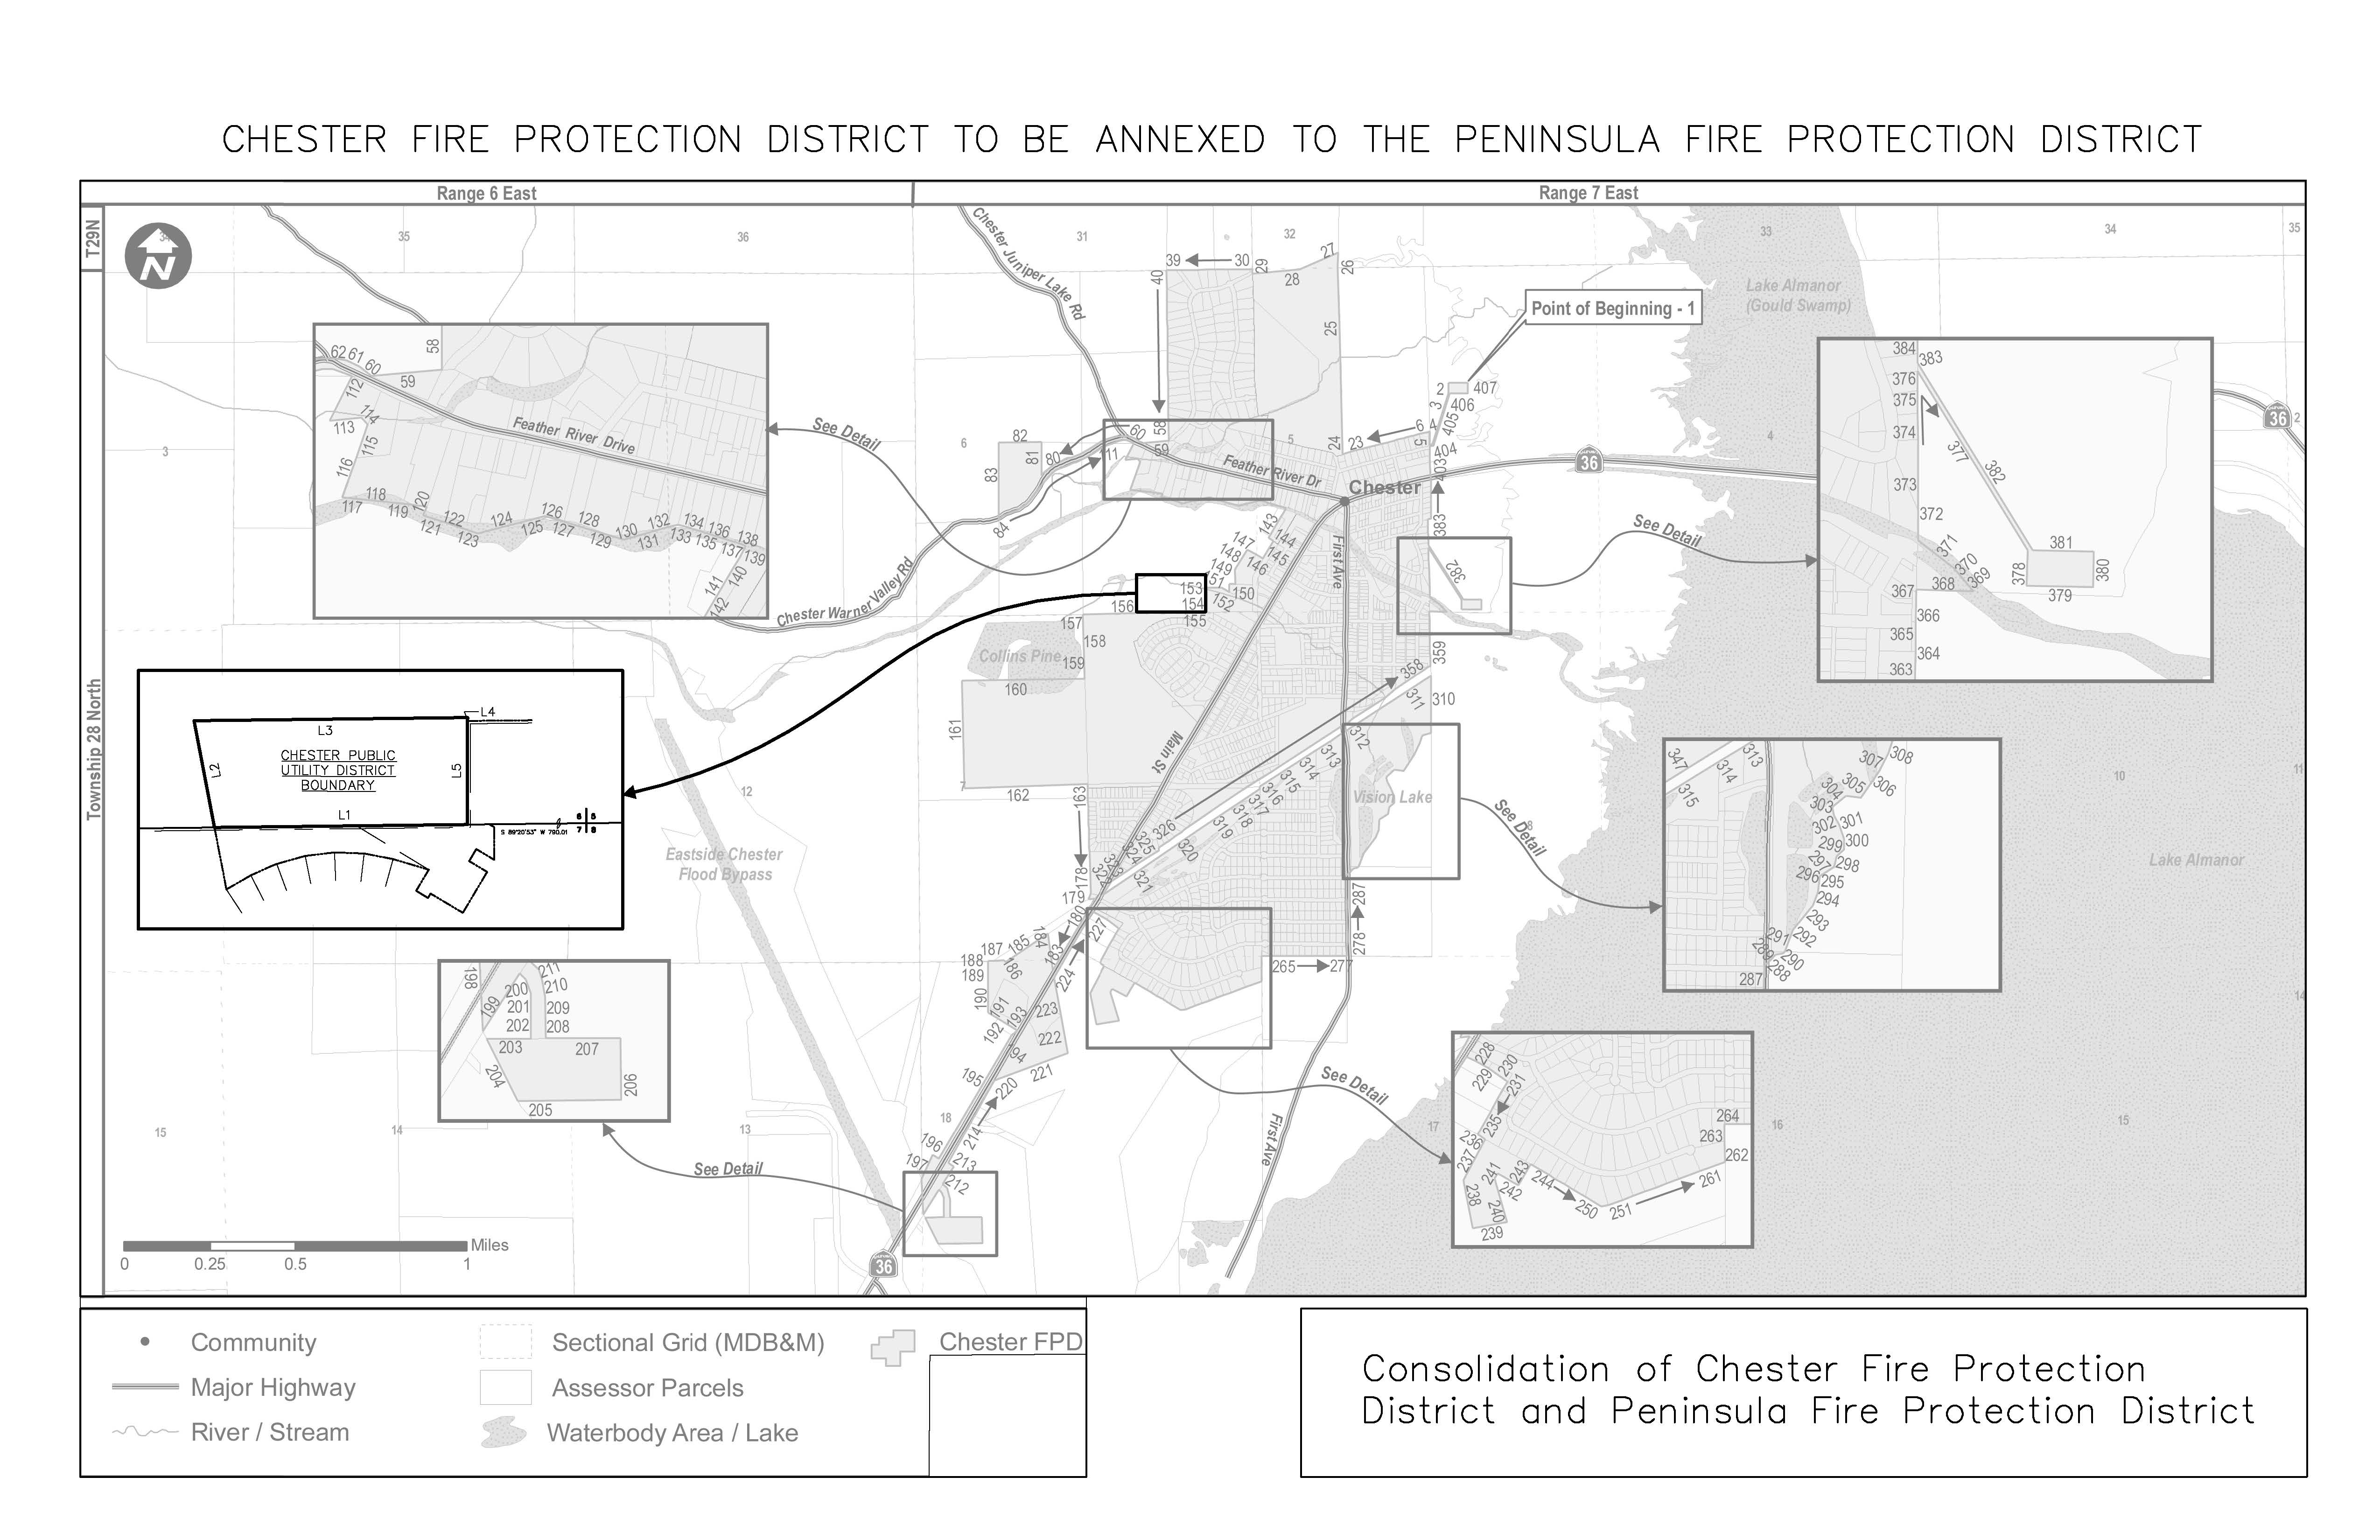

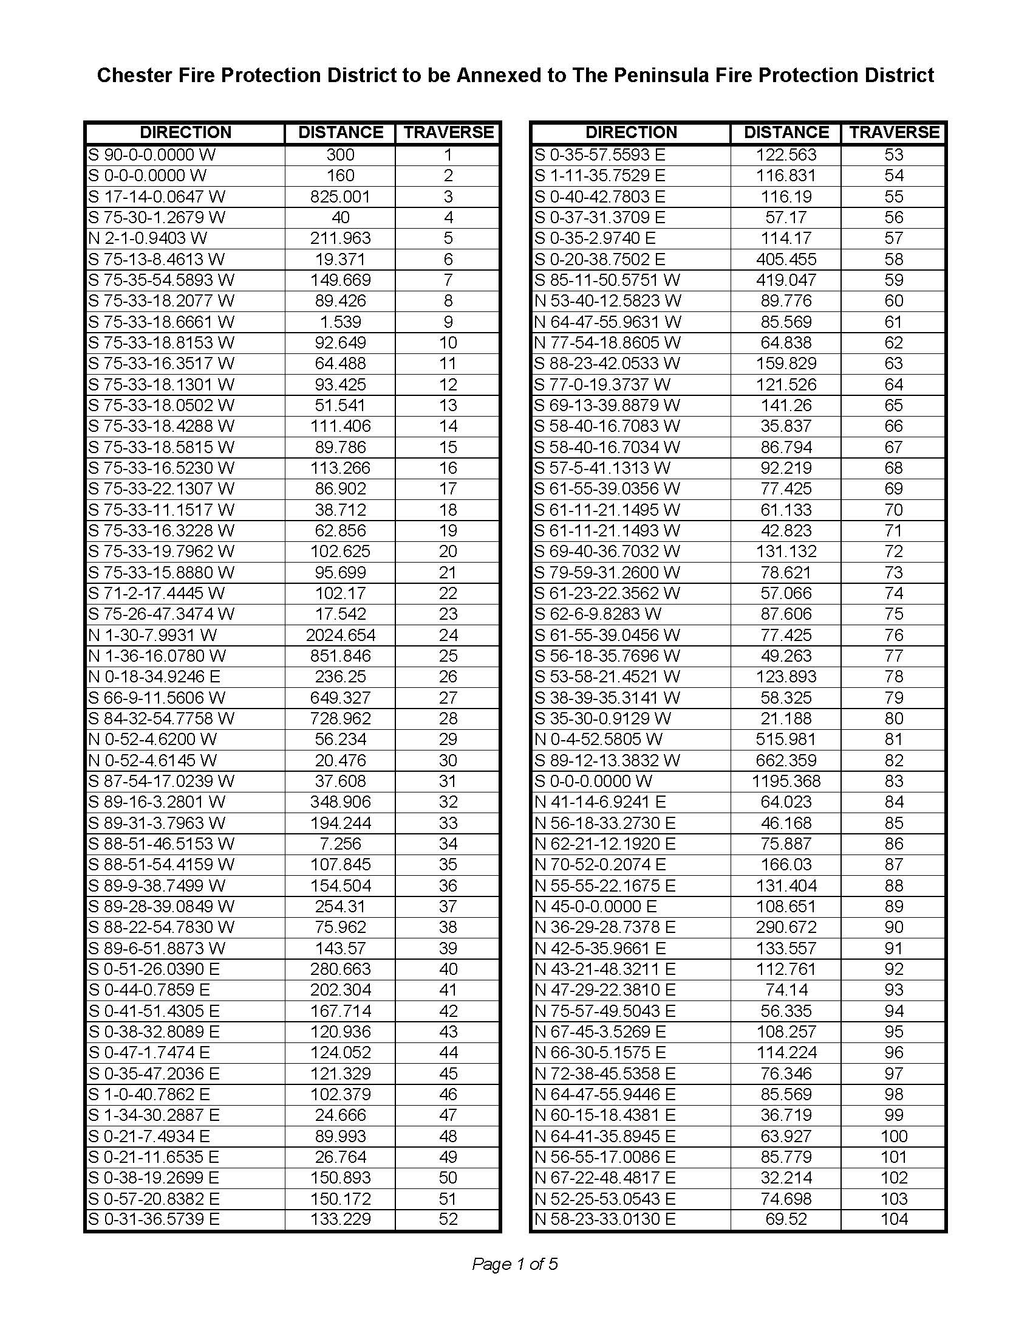

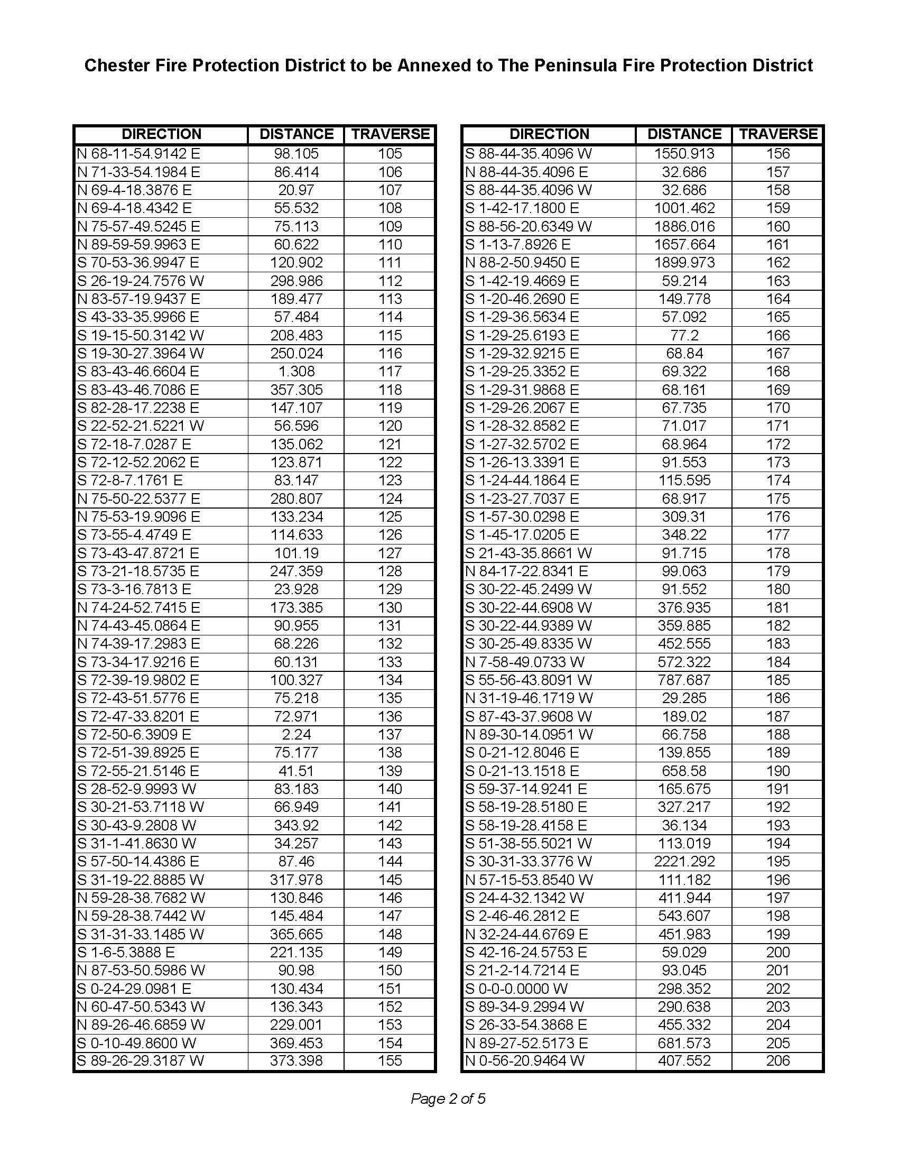

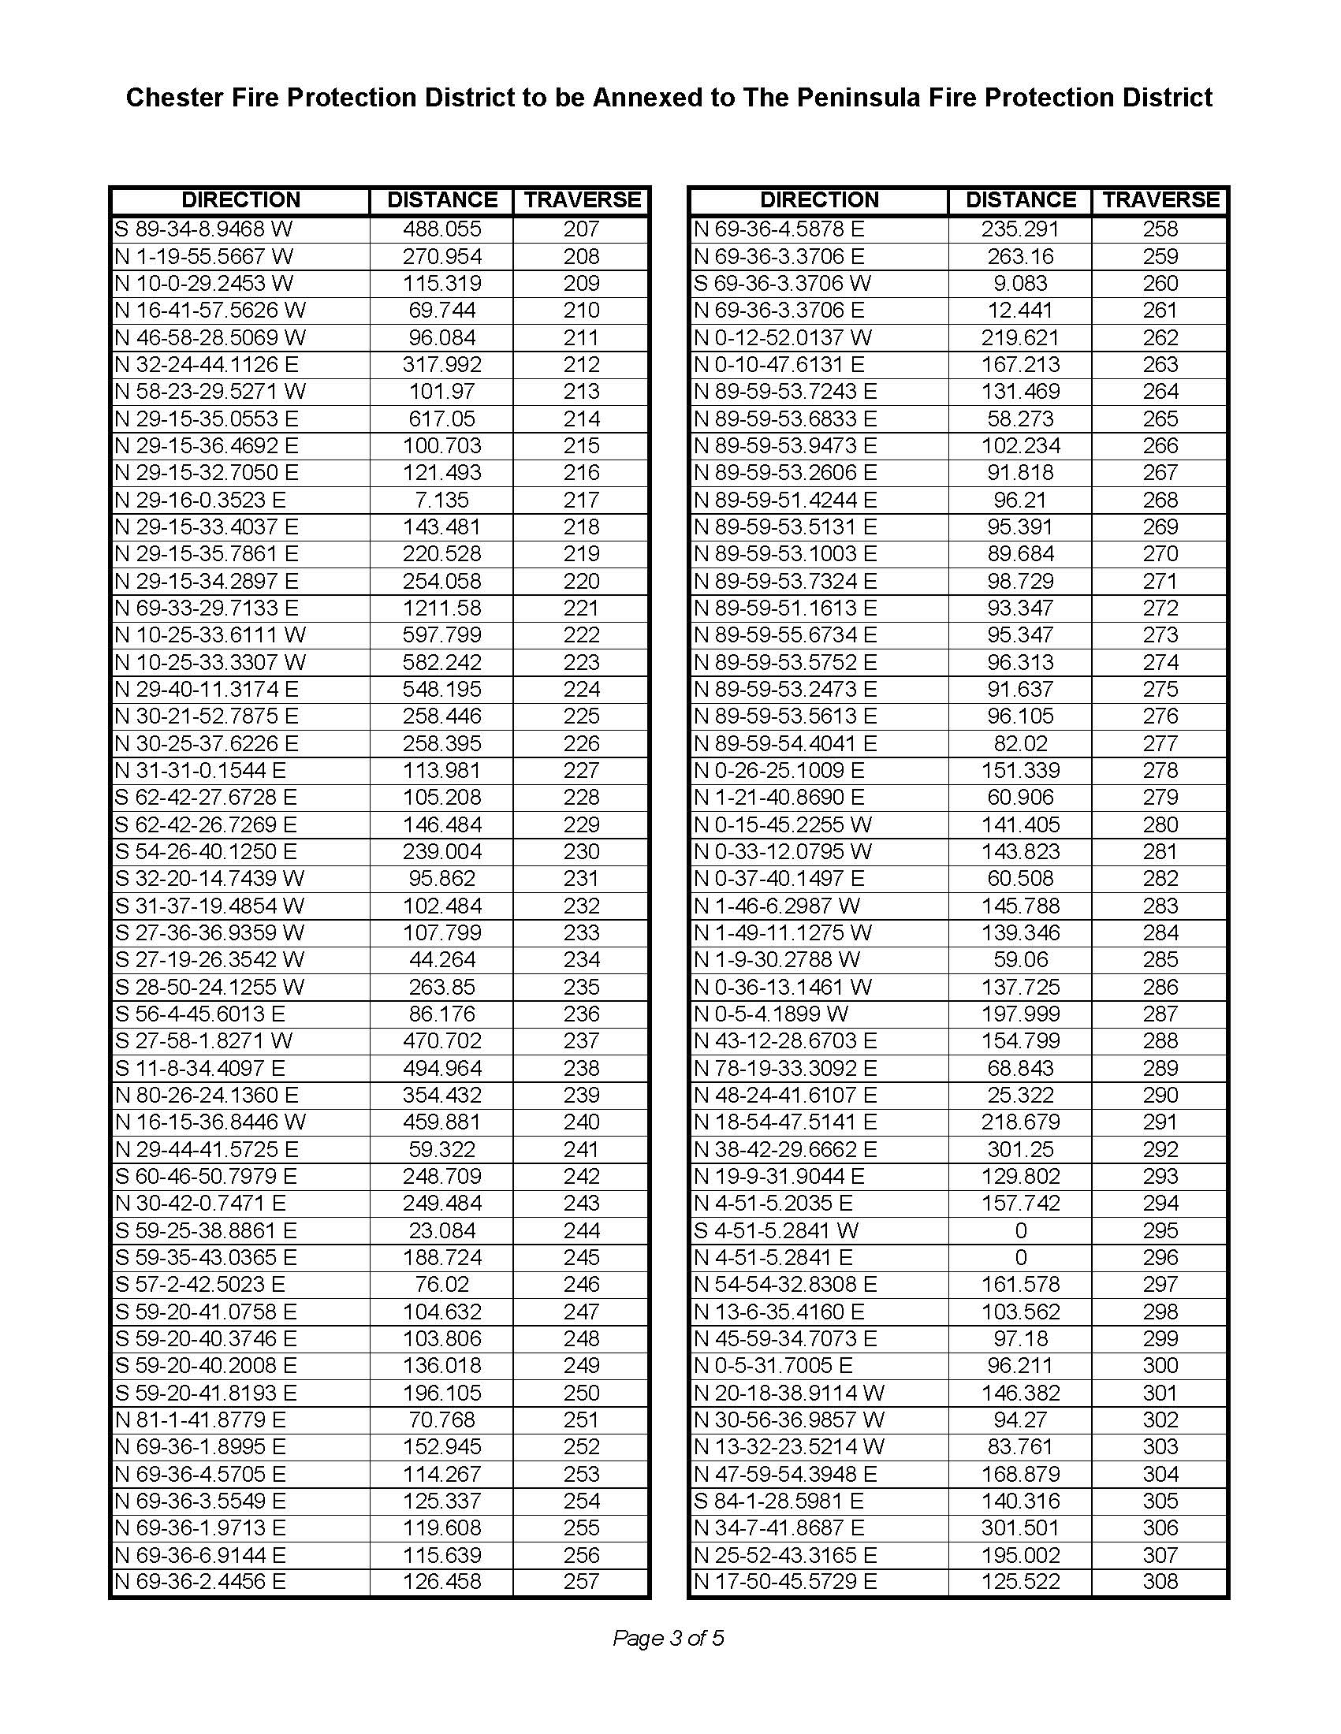

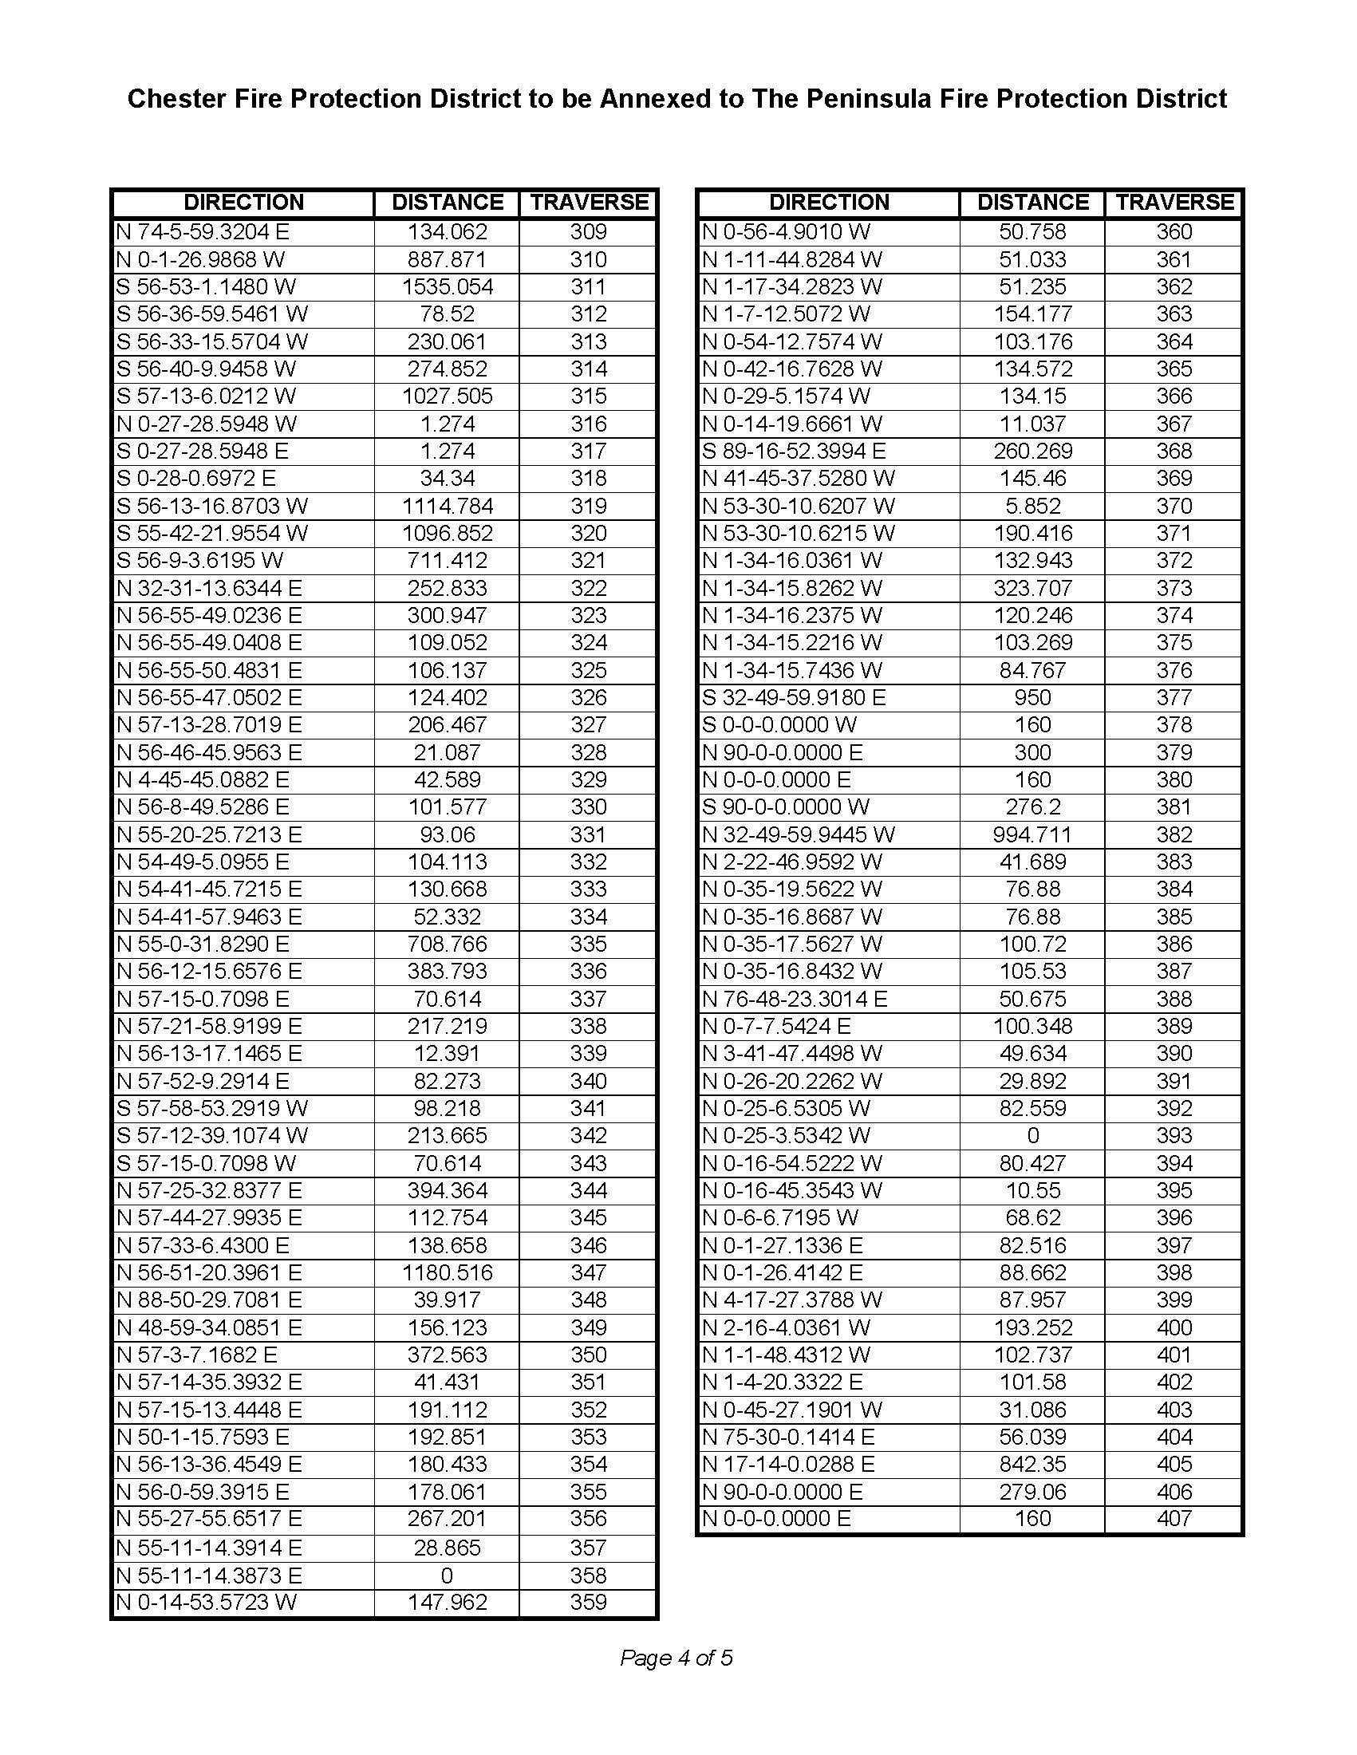

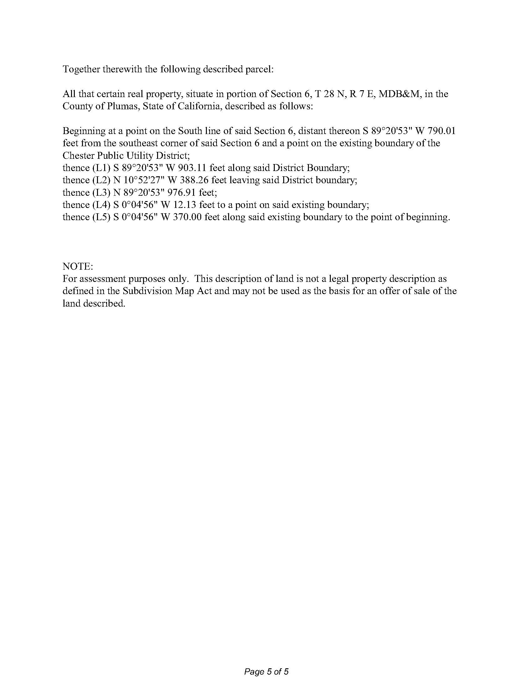

**Exhibit B: Plan for Services**

This plan for service supports the proposed annexation and details how services will be provided and funded by PFPD. It has been prepared according to the information required by §56653(b) of the Cortese-Knox-Hertzberg Local Government Reorganization Act of 2000 (CKH act) which states: (b) The plan for providing services shall include all of the following information and any additional information required by the commission or the executive officer: (1) An enumeration and description of the services currently provided or to be extended to the affected territory. (2) The level and range of those services. (3) An indication of when those services can feasibly be extended to the affected territory if new services are proposed. (4) An indication of any improvement or upgrading of structures, roads, sewer or water facilities, or other conditions the local agency would impose or require within the affected territory if the change of organization or reorganization is completed. (5) Information with respect to how those services will be financed. A plan for services considers the services, capacity, cost and adequacy of services within an area and how those services would be affected by the proposed action.

**Proposed Annexation**

The proposed annexation would serve to consolidate and reorganize services currently provided by CHESTER PUD FIRE SERVICE, including structural fire response, emergency medical response and rescue services, into an existing fire district, PFPD. This annexation will enhance services and response to the communities served by CHESTER PUD FIRE SERVICE and PFPD and will provide consistency in levels of service throughout the entirety of the PFPD boundaries. The consistent and reliable funding sources of PFPD to support services throughout the annexed territory will be carried forward to Chester residences, including,

1. Application of the approved PFPD Special Tax ballot measure dated November 7, 2021, across all parcels within the service territory of CHESTER PUD FIRE SERVICE.
2. CalFire and USFS large incident support response revenue.
3. Fundraising efforts.
4. Ambulance and miscellaneous service fees enacted by the board of directors of PFPD.

Since March 2024, PFPD has provided fire and emergency medical services to CHESTER PUD FIRE SERVICE and has become familiar with its territories, customers, and nuisances, all without compensation to PFPD. Without the ability for CHESTER PUD FIRE SERVICE to re-establish their operations, this annexation provides a path forward for CHESTER PUD FIRE SERVICE, and establishes a revenue source for services already being provided by PFPD.

PFPD will endeavor to adhere to the National Fire Protection Association (NFPA) performance standard for volunteer and other combined fire departments, (NFPA 1720). This standard, among other guidelines, identifies target response time performance for structure fires.

With services already being provided by PFPD to CHESTER PUD FIRE SERVICE, these services are planned to continue and improve through the annexation process.

The annexation will result in the dissolution of the CHESTER PUD FIRE SERVICE. Assets of CHESTER PUD FIRE SERVICE with the exception of real property will be transferred to the PFPD as the successor agency. The PFPD is governed by a five-member board of directors with staggering terms in office and elected by the registered voters residing within the boundaries of the entirety of the district.

**Current Challenges**

**Lack of Revenue to Conduct Business:**

CHESTER PUD FIRE SERVICE has been non-operational since November 1, 2024 with only limited services offered since February 29, 2024. As mentioned in the resolution, CHESTER PUD FIRE SERVICE has attempted to both reduce operating costs and increase tax and non-tax revenues, however the operating deficit under current employee MOUs and service model is not sustainable.

**No Fire Personnel:**

CHESTER PUD FIRE SERVICE ceased operations on November 1, 2024, due to lack of sustainable funding mechanism.

**Strain on Neighboring Fire Agencies to Cover** **Without Compensation:**

Fire districts were formed to provide structure fire and all risk services within a specific jurisdictional boundary where services are supported by revenue from a combination of taxes and fees. When a fire district is unable to provide these services, it places tremendous pressure on neighboring agencies to ensure emergencies are being handled. In the case of CHESTER PUD FIRE SERVICE, the district’s inability to retain employees due to financial problems has increased the use of mutual aid requests and has burdened the neighboring fire departments on a regular basis without compensation.

**Population and Growth**

According to the 2020 Census, the Chester Public Utility District (CPUD) has a population of 2,187 people. Alternately, according to the 2010 Census, the District had a population of approximately 2,144. Accordingly, CPUD's average annual population growth rate (AAGR) from 2010 to 2020 was roughly 0.2 percent. The Department of Finance (DOF) projects a 34 percent decline in Plumas County's population from 2020 (19,847) to 2060 (13,025). This represents an average annual growth rate (AAGR) of negative one percent, indicating an approximate one percent annual population decline from 2020 through 2060. Utilizing the County's AAGR and CPUD's 2020 population estimates, the population within the District is anticipated to decrease to approximately 1,435 by 2060.

According to the 2020 Census, the Peninsula Fire Protection District (PFPD) has a population of 817 people. This is based on the census-designated place (CDP) population for Lake Almanor Country Club CDP (451) and Lake Almanor Peninsula CDP (366). 17Alternately, according to the 2010 Census, the District had a population of approximately 775. 18 Accordingly, PFPD's average annual population growth rate (AAGR) from 2010 to 2020 was roughly 0.53 percent. The Department of Finance (DOF) projects a 34 percent decline in Plumas County's population from 2020 (19,847) to 2060 (13,025). This represents an average annual growth rate (AAGR) of negative one percent, indicating an approximate one percent annual population decline from 2020 through 2060. Utilizing the County's AAGR and PFPD's 2020 population estimates, the population within the District is anticipated to decrease to approximately 536 by 2060.

It should also be noted that there is a significant seasonal variation in population, particularly as it relates to tourists and resort facilities within the area.

|  |  |
| --- | --- |
| **Affected Agency** | **Population** |
| Chester PUD | 2,187 |
| Peninsula FPD | 817 |
| Total Proposed Population Served | 3,004 |

Source: Plumas LAFCo Municipal Service Review + SOI Update CPUD & PFPD 10/2024

**Sphere of Influence**

Chester’s SOI extends beyond the District's boundaries in several directions: south beyond Rogers Field Airport and State Routes 36 and 89; southwest along Chester Ski Road; west along Chester Warner Valley Road; east along Fourth Avenue and Melissa Avenue, reaching towards the southeast of SR 36 near Lake Almanor; and north of Last Chance Creek and Mud Creek. The PFPD Sphere of Influence will require an amendment to include the territory within CHESTER PUD FIRE SERVICE prior to the annexation for consistency.

**Infrastructure Needs**

Chester PUD will retain ownership of the 198 Main Street facility as well as 251 Airport Road as part of their continued water and sewer operation. A long-term lease will be negotiated between CPUD and PFPD for housing equipment and personnel in one of the properties. By leasing the facility it will put the responsibilities of building maintenance on CPUD, thus providing PFPD with a fixed cost for facilities in the Chester community. The terms of the lease are still under review and will be presented as soon as it is completed.

**Exhibit C: Schedule of Asset Transfer**

**Schedule of Asset Transfer**

Upon completion and certification of annexation, CPUD Fire Department shall transfer the following personal property to PFPD. This list does not preclude a further transfer of property in the future.

|  |  |  |  |  |  |
| --- | --- | --- | --- | --- | --- |
| Engine T1 | 7221 | Pierce | 2004 |  |  |
| Ladder Truck | 7261 | Peirce |  |  |  |
| Ambulance | 7252 | Dodge 4500 |  |  |  |
| Utility | 7200 | Chevy Tahoe | 2021 |  |  |
| Utility | 7204 | Chevy Tahoe | 2021 |  |  |
| Utility | 7251 | Ram 1500 | 2008 |  |  |
| **Radios:**   |  |  |  |  |  |  | | --- | --- | --- | --- | --- | --- | | Mobile BK | TBD |  |  |  |  | | Portable BK | P150 | 5 |  |  |  |   **SCBA:**   |  |  |  | | --- | --- | --- | | MSA Packs | 12 |  | | MSA Masks | TBD |  | | MSA Bottles | 25 |  |   **Structural PPE:**   |  |  |  | | --- | --- | --- | | Jackets | 37 |  | | Pants | 62 |  | | Helmets |  |  |   **EMS Equipment:**   |  |  |  |  | | --- | --- | --- | --- | | Zoll Cardiac Monitor | 2 |  |  | | AED | 2 |  |  | | Stryker E Gurney | 2 |  |  | | Portable Suction | 4 |  |  |   **Fire Hose:**   |  |  |  | | --- | --- | --- | | DJ 1.5” | 84 |  | | DJ 2” | 15 |  | | DJ 1.75” | 42 |  | | LDH 5” | 36 |  | | SJ 1” | 64 |  | | SJ 1.5” |  |  |   **Miscellaneous Tools & Equipment:**   |  |  |  |  |  |  | | --- | --- | --- | --- | --- | --- | | Hydraulic Rescue Systems (Jaws of life) | 2 |  |  |  |  | | Stihl Chainsaw | 5 |  |  |  |  | | Echo Chainsaw | 1 |  |  |  |  | | Honda Light Generator | 3 |  |  |  |  | | PPV Blower Gas | 1 |  |  |  |  | | PPV Blower Electric | 1 |  |  |  |  | | Wolf Pack (wildland ppe) | 31 |  |  |  |  | | Ladders: |  | (3) 24’ | (3) attic | (2) 16’ |  | |  |  |  |  |  |

**Exhibit D: Post-Annexation F****inancial Plan**

**Financial Plan**

The Annexation of CHESTER PUD FIRE SERVICE will be effective January 1, 2025, however until assessments can be collected PFPD will continue to maintain its current staffing level and respond out of one of the 2 PFPD fire stations for calls for service in Chester. Using a proposed budget, estimates were made to include CHESTER PUD FIRE SERVICE costs of operation once assessments are collected and dispersed to PFPD. Initial estimates indicate the two sources of revenue will be sufficient to provide services to the district.

There are no plans to finance services. It is anticipated that all services post-annexation will be administered through identified revenue sources.

**2021 Peninsula Fire Protection District Special Tax**

Owners of developed and undeveloped parcels within the boundaries of CHESTER PUD FIRE SERVICE will be assessed the 2021 PFPD voter approved annual Special Tax at the parcel level as is currently administered by PFPD. The application of the PFPD Special Tax across all parcels within the territory of CHESTER PUD FIRE SERVICE and a conservative projection of ambulance billing for service is expected to generate $916,000.00 in revenue for PFPD. The application of this tax is not subject to a ballot measure for voters within the CHESTER PUD FIRE SERVICE.

The first Plumas County filing of the Special Tax for CHESTER PUD FIRE SERVICE property owners requesting the County to collect the tax will occur on the October 2025 Plumas County Property Tax Statements. CHESTER PUD FIRE SERVICE property owners will see the first billing on their October 2025 property tax bill.

**AMBULANCE BILLING FOR SERVICE**

PFPD will continue to bill for ambulance transport using the set billing rates adopted by the PFPD board of directors. A conservative estimate of billing shows that it is reasonable to assume that PFPD will collect at least $300,000 annually for services in Chester and West Shore FPD.

**INCIDENT SUPPORT DIVISION**

PFPD will continue to administer the Chester PUD Fire Service incident support division for response and support of large Cal Fire and Forest Service incidents. Due to the inconsistent nature of this revenue, any excess revenues from the incident support division will be allocated to build reserves and is not accounted for in the operating budget at this time.

**CHESTER PUD FIRE SERVICE SPECIAL ASSESMENT**

The special assessment of $95.00 (improved parcels) and $75.00 (unimproved parcels) for fire service in the Chester community will remain in place and will be used by CPUD to repay the CPUD Sewer Fund and PERS retirement termination liability. Once the debt has been repaid, the assessment in Chester will cease.

**CHESTER AD VALOREM TAX**

The ad valorem tax collected in the Chester community will also be used to repay the CPUD Sewer Fund and PERS retirement termination liability. Once the debt has been repaid the Chester ad valorem tax will be forwarded to PFPD to be used for fire service operations in Chester.

**Conclusion:**

The Peninsula FPD will build and sustain adequate community fire and advanced life support services for the Chester area and the entire region that is equitably supported in the communities served. By annexing Chester, increased funding paired with more efficient use of regional resources will provide consistent levels of service throughout the communities served and will ensure consistency in fire fighter training, personal protective equipment, emergency medical and firefighting equipment, and apparatus equipment, as well as to improve response times and operational efficiencies. This will be accomplished through hiring 3 additional Firefighter Paramedics and onboarding additional Per Deim Firefighter EMTs required to properly staff the Chester community. The overall objective is to include Chester residents with a cost effective, well trained, and professional fire agency for years to come through the implementation of modern and efficient programs.

**District Dissolution:**

The Chester PUD fire service will be dissolved. Identified personal property assets belonging to Chester PUD fire service will be transferred to Peninsula FPD and as such, the Peninsula FPD will be the successor for the dissolved district in accordance with §57451(d) of the CKH Act. Should Peninsula FPD be unsuccessful in negotiating a tax exchange agreement with Plumas County or, either agency otherwise fails to meet the conditions of approval for annexation, then the Chester PUD Fire Department will not be dissolved. They will retain their assets and powers to provide fire and emergency response services.

|  |  |  |  |  |  |
| --- | --- | --- | --- | --- | --- |
|  | | **Chester Fire Preliminary Budget**  **Peninsula Fire**  **2025/2026** | |  | |
|  | |  | |  | |
| **Account #** | | **Salaries and Benefits** | | **Budget 25/26** | |
|  | | **Description** | |  | |
| 51000 | | Regular Wages FT medic step 3+ Per Deim EMT | | 384,299.60 | |
| 51020 | | Other wages | | 0 | |
| 51040 | | Holiday Pay | | 11,188.80 | |
| 51060 | | Overtime Wages | | 15,104.88 | |
| 51070 | | Unemployment Insurance | | 3,000.00 | |
| 51080 | | PERS | | 55,424.61 | |
| 51090 | | Group Insurance | | 84,924.30 | |
| 51100 | | OASDI - FICA & Medicare Deductions | | 0 | |
| 51110 | | Compensation Insurance | | 60,000.00 | |
| 51140 | | Clerical Wages | | 35,200.00 | |
|  | |  | |  | |
|  | |  | |  | |
|  | |  | |  | |
|  | | **Total Labor Costs** | |  | |
|  | |  | | **$649,142.19** | |
|  | | **Services and Supplies** | |  | |
|  | |  | |  | |
| **Account #** | | **Description** | |  | |
|  | | Clothing -Personal Supply | |  | |
| 52010 | | Communications | | 12,000.00 | |
| 52020 | | Insurance - District and Liability | | 15,347.00 | |
| 52050 | | Maintenance - Equipment | | 81,996.00 | |
| 52090 | | Maintenance - Trucks | | 12,000.00 | |
| 52092 | | Vehicle Fuel | | 31,000.00 | |
| 52110 | | Maintenance - Building and Grounds | | 14,000.00 | |
| 52130 | | Office Expense | | 1,500.00 | |
| 502180 | | Professional Services | | 5,000.00 | |
| 52190 | | Publications - Legal Notices | | 5,000.00 | |
| 52370 | | Rents and Leases | | 500.00 | |
| 52380 | | Heating | | 14,400.00 | |
| 52390 | | Special Dept. Expense -Station Items | | 5,000.00 | |
| 52440 | | Special Dept. Other - Non-Safety Equipment | | 2,000.00 | |
| 52470 | | Special Dept. Tax & Assessment Admin Fee | | 2,000.00 | |
| 52550 | | Special Dept. - Medical Supplies | | 7,500.00 | |
| 52710 | | Travel Routine - In County | | 10,000.00 | |
| 52740 | | Travel Routine - Out of County | | 500.00 | |
| 52750 | | Utilities | | 500.00 | |
| 52780 | | Contingencies | | 16,000.00 | |
| 52840 | | Apparatus Vehicle Loan re-payment | | 0.00 | |
| 52950 | | Fire Calls | | 0.00 | |
| 52960 | | Training | | 5,000.00 | |
|  | |  | | 10,000.00 | |
|  | | **Total Services and Supplies** | |  | |
|  | |  | | **$251,243.00** | |
|  | |  | |  | |
|  | | **Tax Revenue** | |  | |  | |  |
| **Account #** | | **Description** | |  | |  | |  |
|  | |  | |  | |  | |  |
|  | |  | |  | |  | |  |
|  | |  | |  | |  | |  |
| 40130 | | Ambulance Billing | | $300,000 | |  | |  |
| 40150 | | Special Assessment | | $616,000 | |  | |  |
|  | |  | |  | |  | |  |
|  | | **Total Revenue** | | **$ 916,000.00** | |  | |  |
|  | | **Total Labor** | | **$ 649,142.19-** | |  | |  |
|  | | **Total Service and Supply** | | **$ 251,243.00-** | |  | |  |
|  | |  | |  | |
|  | | **Total: $15,614.81** | |  | |
|  | |  | |  | |
|  | |  | |  | |
|  | |  | |  | |
|  | |  | |  | |
|  | |  | |  | |
|  | |  | |  | |
|  | |  | |  | |
|  | |  | |  | |
|  | |  | |  | |
|  | |  | |  | |
|  | |  | |  | |
|  | |  | |  | |
|  | |  | |  | |
|  | |  | |  | |
|  | |  | |  | |
|  | |  | |  | |
|  | |  | |  | |
|  | |  | |  | |
|  | |  | |  | |
|  | |  | |  | |
|  | |  | |  | |
|  | |  | |  | |
|  | |  | |  | |
|  | |  | |  | |

**Exhibit E: Peninsula Fire Protection District Special Tax**